1) Write a query to find the addresses (location_id, street_address, city, state_province, country_name) of all the departments.   
Hint : Use NATURAL JOIN

ANSWER:

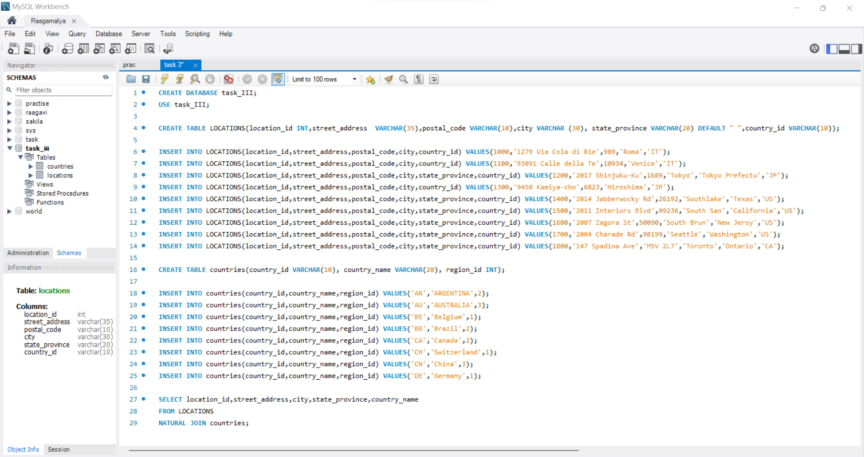

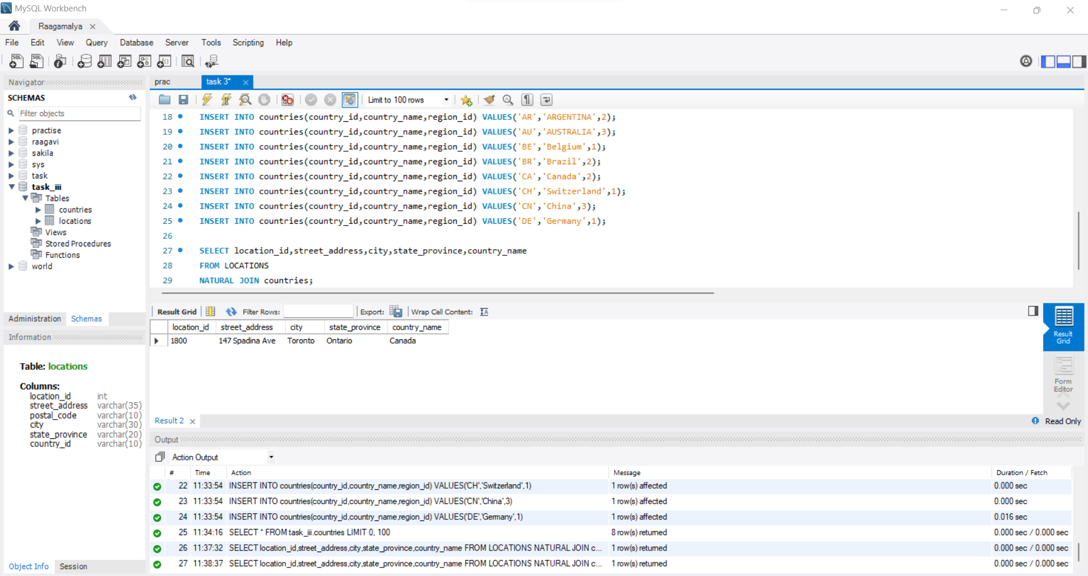

2) Write a query to find the name (first_name, last name), department ID and name of all the employees.

ANSWER:

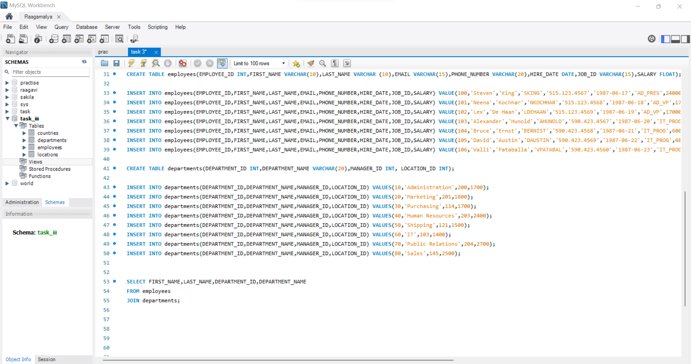

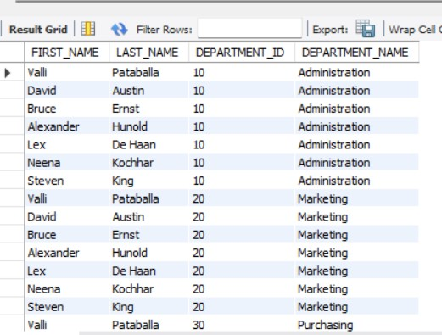

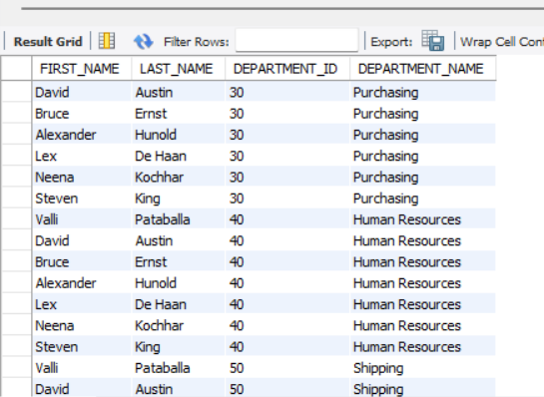

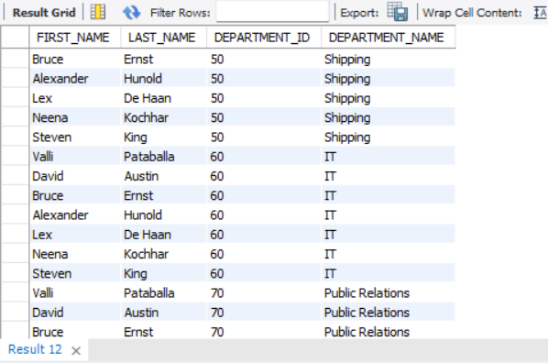

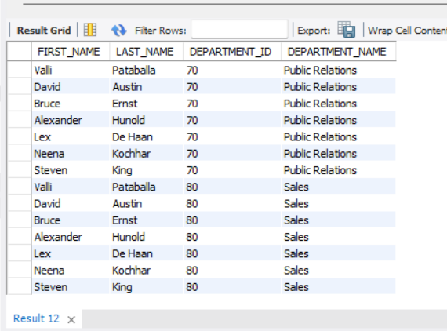

3) Write a query to find the name (first_name, last_name), job, department ID and name of the employees who works in London.

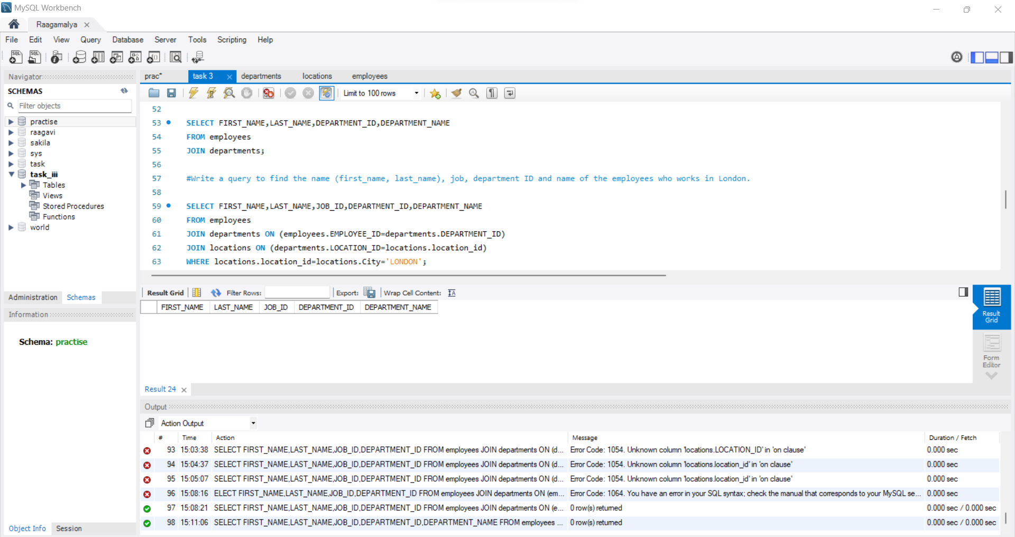

4) Write a query to find the name (first_name, last_name) and the salary of the employees who have a higher salary than the employee whose last_name='Bull'.

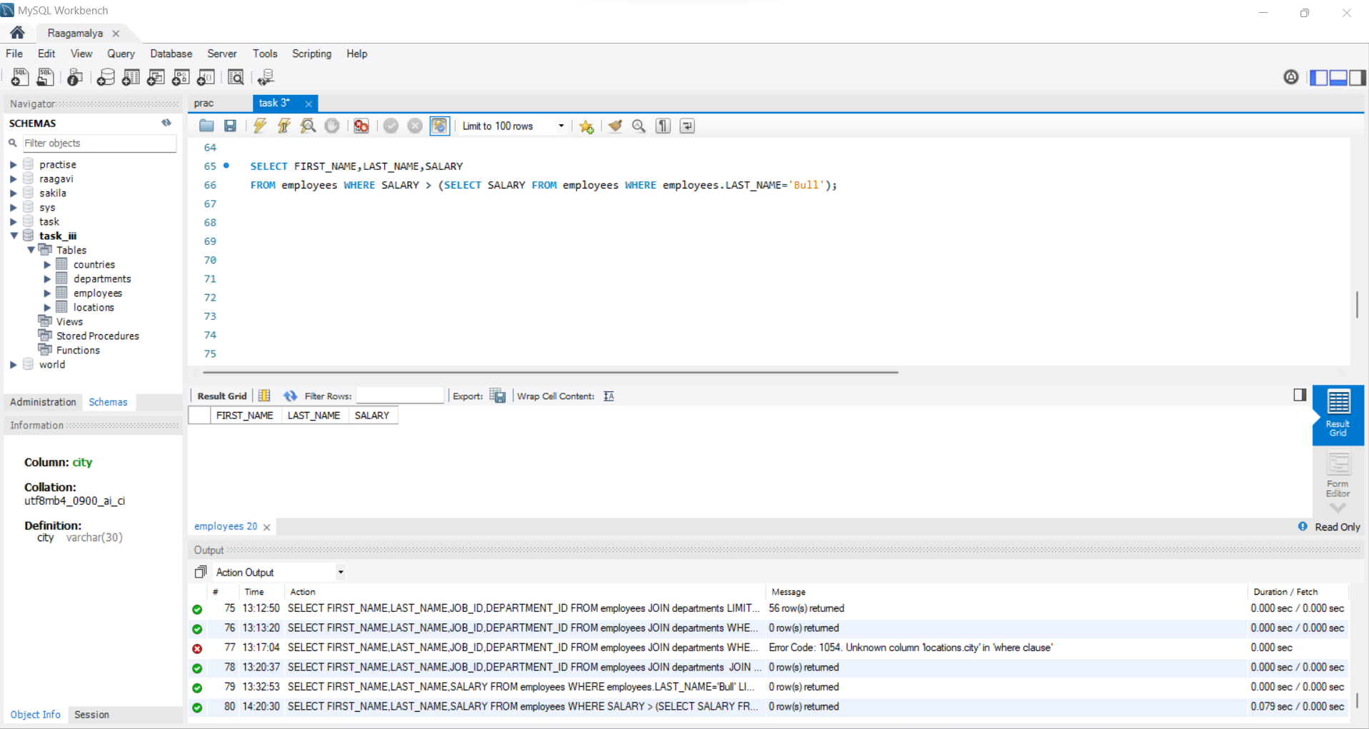

5) Write a query to find the name (first_name, last_name) of the employees who have a manager and worked in a USA based department.

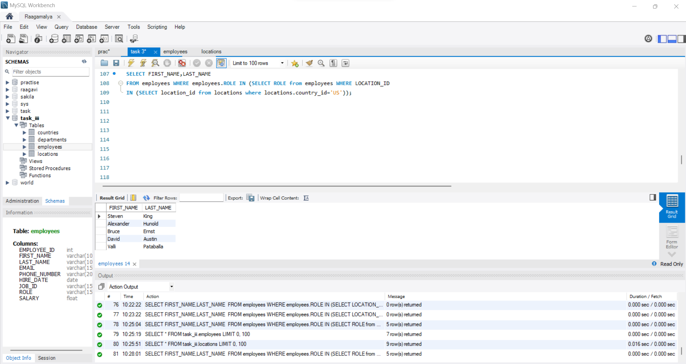

6) Write a query to find the name (first_name, last_name) of the employees who are managers.

